COMMON COURSE ASSIGNMENT

CSA04 – OPERATING SYSTEMS Covering CO2, CO3 & CO4

Design and Analysis of an OS Resource Orchestration System for a Smart University ("UniCore")

N. SATHWIK (192525077)

S. HARSHAVARDHAN (192524106)
D.DINESH REDDY(192524186)

A. ASSIGNMENT INFORMATION
Particular | Details
Department | Computer Science and Engineering
Programme | B.E. / B.Tech – CSE
Course Code & Course Name | CSA04 – Operating Systems
Academic Year / Batch | 2026 – 2027
Faculty Name | Dr J Priskilla Angel Rani
Assignment Title | Design and Analysis of an OS Resource Orchestration System for a Smart University
Date of Issue | 25-08-26
Date of Submission | 28-08-26
Maximum Marks | 100
Course Outcome(s) – CO | CO2, CO3, CO4
Bloom's Taxonomy Level | L3 – Apply, L4 – Analyse, L5 – Evaluate
SDG Mapping | SDG 7 – Affordable and Clean Energy; SDG 9 – Industry, Innovation and Infrastructure; SDG 11 – Sustainable Cities and Communities
Industry / Societal Relevance | Efficient OS resource management is fundamental to cloud platforms, university servers, digital public services and energy-aware computing.
B. ASSIGNMENT PROBLEM / CHALLENGE
Students are required to design and analyze an Operating System Resource Orchestration System for a smart university. The system must manage a changing workload generated by online examinations, digital classrooms, library services, research jobs, backup services and campus IoT monitoring. The assignment integrates process management, synchronization and deadlock handling, memory management, file allocation and disk scheduling. This report constructs a concrete workload, applies suitable OS algorithms, validates the results using calculations and simulation programs, compares alternatives, and arrives at evidence-based engineering decisions.

C. PROBLEM STATEMENT
UniCore is a university computing platform supporting 500 concurrent users during normal operation and more than 800 users during online examination periods. It provides learning-management services, examination processing, digital-library access, research computing, automated backups and IoT monitoring. Multiple processes compete for CPU time, memory frames, files and I/O devices. Some services are interactive and response-sensitive (examinations, classrooms, library queries), while others are long-running background jobs (research computation, backups, report generation).
As the OS design team, the following three areas are analyzed and integrated:
- Process Management, Synchronization & Deadlock (CO2) – concurrent processes access shared examination records, logs and limited resources without race conditions or unsafe resource requests.
- Memory Management (CO3) – limited physical memory is shared across concurrent services using paging/virtual memory, with page-fault and thrashing control.
- File Systems & Disk Scheduling (CO4) – files ranging from small student records to large lecture recordings are stored and served while balancing access speed, fairness and storage efficiency.

D. REQUIREMENTS AND CONSTRAINTS
- Functional: support concurrent user services and shared-file access without race-condition-induced corruption.
- Workload: at least 8 processes and at least 4 resource types are used for analysis (8 processes, 4 resource types adopted).
- Memory: 16 GB physical RAM and a 4 KB page size are assumed.
- Storage: a 200-cylinder disk (0–199) with 10 pending requests is used for disk-scheduling analysis.
- Reliability: unsafe/deadlock states are identified using the Banker's Algorithm, with an avoidance strategy adopted.
- Performance: average waiting time, page faults and disk-head movement are minimized while preserving fairness.
- Resource limitation: a finite number of database-connection, file-lock, print-queue and network-I/O resources is assumed and clearly allocated.
- Technical: Python is used for simulation of all algorithms (Banker's, CPU scheduling, page replacement, disk scheduling).
- Security/Privacy: shared academic files preserve access control and data integrity through the Readers–Writers protocol.
E. STUDENT WORK

1. PROBLEM UNDERSTANDING AND FORMULATION
Restated problem: UniCore must schedule CPU-bound and I/O-bound academic services fairly during both normal (500-user) and peak examination (800-user) load, while guaranteeing that concurrent access to shared examination records never corrupts data, that memory is not exhausted by concurrently running services, and that disk I/O for files ranging from a few KB (student records) to several GB (lecture recordings) is served with acceptable latency.
Identified challenges:
- CPU: interactive exam-submission and classroom-streaming processes must not be starved behind long research/backup jobs.
- Synchronization: multiple examiners/students read and write shared exam-record files concurrently.
- Memory: 800 concurrent exam sessions during peak load can each touch many pages, risking thrashing if frame allocation is not controlled.
- File system: heterogeneous file sizes (KB to GB) need different allocation strategies for efficiency.
- Disk I/O: many simultaneous disk requests during peak load must be reordered to reduce head movement without starving far-away requests.
Workload and assumptions:
- 8 processes with arrival time, CPU burst and priority (Section E.2, Part I).
- 4 resource types: R1 = Database Connections (10), R2 = File Locks (6), R3 = Print-Queue Slots (4), R4 = Network I/O Channels (8).
- Memory: 16 GB physical RAM, 4 KB page size, 64 MB sample logical address space.
- Disk: 200 cylinders (0–199), initial head at cylinder 53, 10 pending requests.
Measurable objectives:
- Average waiting time, turnaround time and response time per scheduling policy.
- Safe/unsafe state outcome of the Banker's Algorithm for every resource request.
- Total page faults for FIFO, LRU and Optimal at 3 and 4 frames.
- Total disk head movement (in cylinders) for FCFS, SSTF and SCAN.
Constraints the final design must satisfy: bounded resource counts (Banker's Available vector must never go negative), bounded physical frames (4 or 3 in the simulated scenario, scaled conceptually to the full 4,194,304-frame system), a 200-cylinder addressable disk range, and fairness so that no background job is indefinitely postponed (bounded starvation via aging/quantum in Round Robin, and SCAN's bounded wait per cylinder direction).

2. APPLICATION OF COURSE KNOWLEDGE (CO2, CO3, CO4)

Part I – Process Management, Synchronization & Deadlock (CO2)
Q4. Readers–Writers model for shared examination records.
Examiners (writers) update grades while students/staff (readers) view records concurrently. The classic Readers–Writers problem (writers-priority variant, to protect exam-record integrity) is used:
semaphore rw_mutex = 1 // guards the shared exam-record file
semaphore mutex = 1 // guards read_count
semaphore w_mutex = 1 // signals a writer is waiting/active
int read_count = 0
Reader():
wait(w_mutex); signal(w_mutex) // wait if a writer is active/waiting
wait(mutex)
read_count++
if read_count == 1: wait(rw_mutex) // first reader locks out writers
signal(mutex)
ReadExamRecord()
wait(mutex)
read_count--
if read_count == 0: signal(rw_mutex) // last reader releases lock
signal(mutex)
Writer():
wait(w_mutex)
wait(rw_mutex) // exclusive access
WriteExamRecord()
signal(rw_mutex)
signal(w_mutex)

Q5. BANKER'S ALGORITHM – ALLOCATION, MAXIMUM, AVAILABLE AND SAFETY TRACE.
Resources: R1 = DB Connections (Total 10), R2 = File Locks (Total 6), R3 = Print-Queue Slots (Total 4), R4 = Network I/O Channels (Total 8).
Allocation Matrix:
Process | R1 | R2 | R3 | R4
P1-ExamProc | 3 | 1 | 1 | 1
P2-Classroom | 2 | 2 | 0 | 2
P3-LibraryAcc | 1 | 0 | 1 | 1
P4-Research | 2 | 1 | 0 | 1
P5-Backup | 0 | 1 | 1 | 0

Maximum Matrix:
Process | R1 | R2 | R3 | R4
P1-ExamProc | 7 | 3 | 2 | 3
P2-Classroom | 4 | 3 | 1 | 4
P3-LibraryAcc | 3 | 2 | 2 | 2
P4-Research | 6 | 2 | 1 | 3
P5-Backup | 2 | 2 | 1 | 2
Available = Total − ΣAllocation = [2, 1, 1, 3]

Need Matrix (Need = Maximum − Allocation):
Process | R1 | R2 | R3 | R4
P1-ExamProc | 4 | 2 | 1 | 2
P2-Classroom | 2 | 1 | 1 | 2
P3-LibraryAcc | 2 | 2 | 1 | 1
P4-Research | 4 | 1 | 1 | 2
P5-Backup | 2 | 1 | 0 | 2

SAFETY ALGORITHM TRACE (WORK STARTS AT AVAILABLE = [2,1,1,3]):
- Work=[2,1,1,3]. P2's Need=[2,1,1,2] ≤ Work → run P2 → Work += Alloc(P2) = [4,3,1,5].
- P3's Need=[2,2,1,1] ≤ Work → run P3 → Work += Alloc(P3) = [5,3,2,6].
- P4's Need=[4,1,1,2] ≤ Work → run P4 → Work += Alloc(P4) = [7,4,2,7].
- P5's Need=[2,1,0,2] ≤ Work → run P5 → Work += Alloc(P5) = [7,5,3,7].
- P1's Need=[4,2,1,2] ≤ Work → run P1 → Work += Alloc(P1) = [10,6,4,8].
Safe sequence: ⟨P2, P3, P4, P5, P1⟩ → System is in a SAFE state
Q6. ADDITIONAL REQUEST THAT MAKES THE SYSTEM UNSAFE.
P3-LibraryAcc requests (2, 1, 1, 0) additional units of (R1, R2, R3, R4).
- Step 1 – Request ≤ Need(P3)=[2,2,1,1]? Yes (2≤2, 1≤2, 1≤1, 0≤1).
- Step 2 – Request ≤ Available=[2,1,1,3]? Yes (2≤2, 1≤1, 1≤1, 0≤3).
- Step 3 – Tentatively allocate: Available becomes [0,0,0,3], Allocation(P3) becomes [3,1,2,1], Need(P3) becomes [0,1,0,1].
- Step 4 – Re-run safety algorithm on the tentative state: no process's Need can be met from Work=[0,0,0,3] (every remaining process needs R1 or R2, both now 0) → NOT SAFE.
Decision: the request is DENIED and P3 is made to WAIT; the previous safe allocation is restored. This is the Banker's Algorithm's deadlock-avoidance behaviour in action.

Q7. DEADLOCK PREVENTION VS AVOIDANCE VS DETECTION VS RECOVERY FOR UNICORE.
Strategy | Mechanism in UniCore | Trade-off
Prevention | Break one of Coffman's conditions, e.g. request all DB/file-lock resources for an exam session at once (no hold-and-wait). | Simple but reduces concurrency and wastes resources that are reserved but idle.
Avoidance (adopted) | Banker's Algorithm runs on every resource request from exam, classroom, library, research and backup processes (Q5–Q6). | Needs Maximum-claim declarations in advance; low runtime overhead for a bounded resource set — well suited to UniCore's known service types.
Detection | Periodic wait-for-graph / resource-allocation-graph cycle check for background research/backup jobs that do not pre-declare Maximum. | Allows more concurrency but requires a recovery plan and periodic overhead.
Recovery | Process termination or resource preemption (e.g., roll back a non-critical backup job) once a cycle is detected. | Only used as a fallback for jobs outside the Banker's-controlled resource pool.
Justification: Banker's Algorithm (avoidance) is selected as the primary strategy because UniCore's core services (exam, classroom, library, research, backup) have well-known Maximum resource claims (Q5), and avoidance keeps resource utilisation higher than prevention while avoiding the periodic-overhead and rollback cost of pure detection/recovery. Detection+recovery is retained only as a secondary safety net for ad-hoc IoT/monitoring processes whose resource needs are not known in advance.

Q8. EFFECT OF CPU SCHEDULING POLICY ON INTERACTIVE VS BACKGROUND SERVICES.

Workload (8 processes):
Process | Arrival | Burst | Priority | Service Type
P1-ExamSubmit | 0 | 6 | 1 | Interactive (Exam)
P2-ExamGrading | 1 | 4 | 1 | Interactive (Exam)
P3-Classroom | 2 | 8 | 2 | Interactive (LMS)
P4-LibraryQuery | 3 | 3 | 2 | Interactive (Library)
P5-ResearchJob | 4 | 12 | 4 | Background (Research)
P6-BackupSvc | 5 | 10 | 5 | Background (Backup)
P7-IoTMonitor | 0 | 5 | 3 | Interactive (IoT)
P8-ReportGen | 6 | 7 | 4 | Background (Reports)
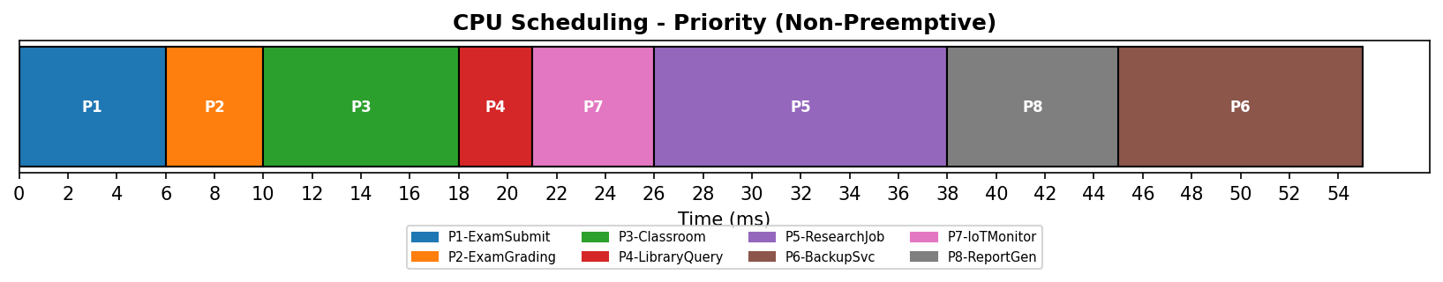
Figure E-1: Gantt chart – Priority (non-preemptive) scheduling.
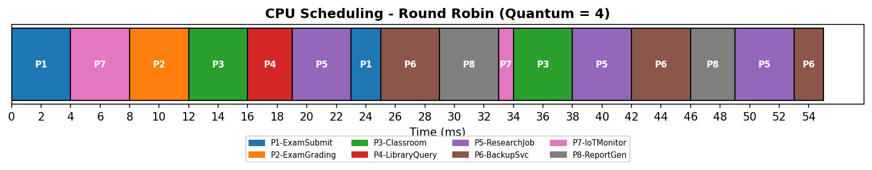
Figure E-2: Gantt chart – Round Robin (quantum = 4).
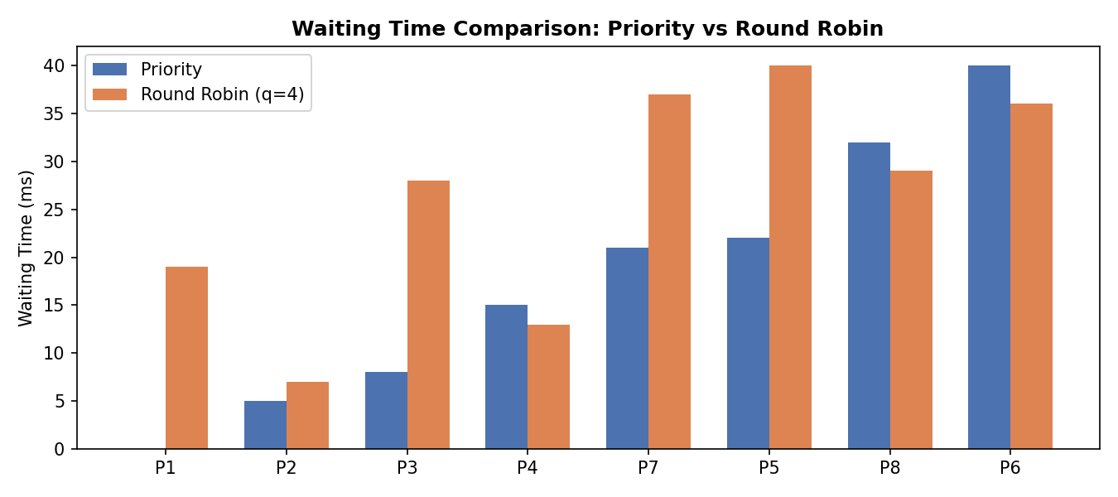
Figure E-3: Per-process waiting time, Priority vs Round Robin.
Metric | Priority (Non-Preemptive) | Round Robin (q=4)
Average Waiting Time | 17.88 ms | 26.12 ms
Average Turnaround Time | 24.75 ms | 33.00 ms
Average Response Time | 17.88 ms | 11.50 ms
Analysis: Priority scheduling gives the two exam processes (priority 1) the lowest possible waiting time (0 ms and 5 ms) because they always run before classroom/library/background work, but it makes background jobs (P6-BackupSvc, waiting 40 ms) wait very long — acceptable, since backups are not user-facing. Round Robin gives a far lower average response time (11.50 ms vs 17.88 ms) because every process, including background jobs, gets CPU time within one quantum cycle, which is important when interactive classroom/library sessions must not feel frozen behind a long research job — but its average waiting/turnaround time is worse due to context-switch style time-slicing. UniCore therefore benefits from a hybrid: Priority scheduling with aging for exam/classroom traffic, and Round Robin (or a low-priority RR queue) for background research/backup/report jobs, i.e., a Multilevel Feedback Queue.

PART II – MEMORY MANAGEMENT (CO3)
Q9. FRAME AND PAGE CALCULATION.
- Physical memory = 16 GB = 16 × 1024 × 1024 KB = 16,777,216 KB; Page size = 4 KB.
- Number of frames = 16,777,216 KB ÷ 4 KB = 4,194,304 frames (2^22 frames).
- Logical address space = 64 MB = 65,536 KB; Number of pages = 65,536 ÷ 4 = 16,384 pages (2^14pages).
Page-table organisation: with 2^22 frames, a frame number needs 22 bits, and with 2^14 pages per process, the page number needs 14 bits (offset = 12 bits for the 4 KB page, since 2^12 = 4096). A flat single-level page table per process would need 16,384 entries; for the platform-wide address space, UniCore uses a two-level (hierarchical) page table so that unused regions of a process's 64 MB space do not consume page-table memory, and a TLB (Translation Look-aside Buffer) caches the most recently used entries to keep address translation fast for the 800-user peak load.

Q10. REFERENCE STRING AND PAGE REPLACEMENT COMPARISON.
Reference string (20 references, representative of a peak exam session touching answer-sheet, question-bank and media pages): 7, 0, 1, 2, 0, 3, 0, 4, 2, 3, 0, 3, 2, 1, 2, 0, 1, 7, 0, 1
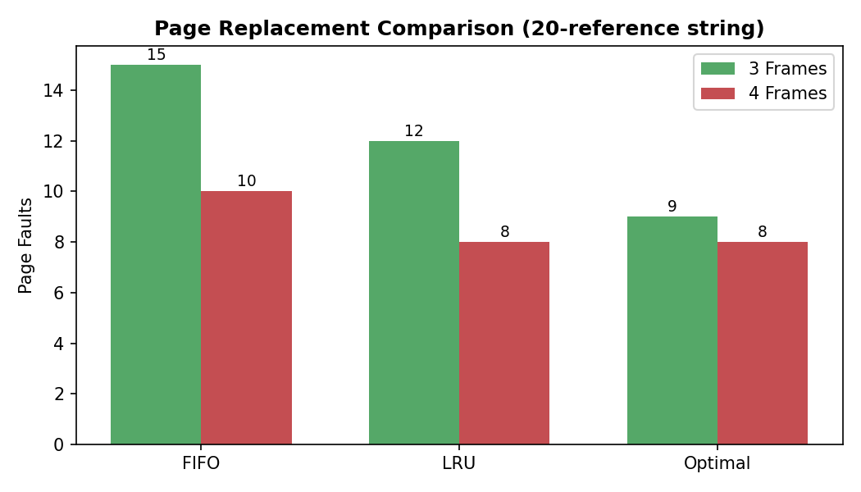
Figure E-4: FIFO vs LRU vs Optimal page faults at 3 and 4 frames.
Algorithm | 3 Frames – Page Faults | 4 Frames – Page Faults
FIFO | 15 | 10
LRU | 12 | 8
Optimal | 9 | 8
Optimal produces the fewest faults at both frame counts (as guaranteed by theory), LRU consistently beats FIFO because it exploits recency, and FIFO is worst because it discards the oldest page even if it is about to be reused.
Q11. DOES INCREASING FRAMES ALWAYS REDUCE FAULTS? BELADY'S ANOMALY.
For the UniCore reference string above, increasing frames from 3 to 4 reduced faults for every algorithm (FIFO 15→10, LRU 12→8, Optimal 9→8) — so no anomaly occurs here. However, increasing frames does not always help for FIFO in general. Using the classical Belady reference string 1, 2, 3, 4, 1, 2, 5, 1, 2, 3, 4, 5:
Frames | FIFO Page Faults
3 | 9
4 | 10
Here FIFO produces MORE faults with 4 frames than with 3 — this is Belady's Anomaly. It occurs because FIFO's replacement order is not based on a stack property (a page kept by k frames is not guaranteed to still be kept by k+1 frames). LRU and Optimal are stack algorithms and never exhibit this anomaly. Conclusion: increasing frames generally helps but is only guaranteed to help for stack-based algorithms (LRU, Optimal) — a relevant caution if UniCore's frame allocator is ever changed to FIFO for simplicity.
Q12. DEMAND PAGING, WORKING SETS AND THRASHING FOR THE 800-USER EXAM WORKLOAD.
Under demand paging, a page is loaded only on first reference (a page fault), which keeps initial memory footprint low when 800 exam sessions start together. Each session's working set — the set of pages it actively touches during a time window (question rendering, answer buffer, submission handler) — must fit in its allocated frames, or the process will fault repeatedly. If the sum of all working sets exceeds the 4,194,304 available frames, thrashing occurs: the CPU spends more time servicing page faults than executing exam logic, and system-wide throughput collapses even though the CPU appears busy.
Proposed policy: a working-set-based frame allocator that (a) measures each session's recent working-set size over a sliding window, (b) grants frames proportional to measured working-set size (variable/local allocation, not a fixed per-process count), and (c) if global page-fault rate crosses a high-water mark, admission control temporarily queues new exam-session logins rather than starting them and pushing the system into thrashing — trading a short login queue for guaranteed low-latency service to sessions already running.
Q13. LINKING AND STORAGE REQUIREMENTS VS MEMORY UTILISATION.
Static linking of UniCore's exam-engine, classroom-streaming and library-indexing binaries would duplicate common libraries (crypto, JSON parsing, video codec) in every process's image, inflating both disk footprint and the number of resident pages per process. Dynamic linking / shared libraries let hundreds of concurrent exam-session processes map the same physical frames for shared library code (via copy-on-write, read-only shared pages), so the effective per-process memory cost during the 800-user peak is dramatically reduced, directly reducing the pressure that leads to thrashing (Q12) and freeing frames for actual working-set data.
PART III – FILE SYSTEMS & DISK SCHEDULING (CO4)
Q14. Contiguous vs linked vs indexed allocation.
File Category | Contiguous | Linked | Indexed (Recommended)
Small student records (KB) | Fast but causes external fragmentation as many small files are created/deleted. | Avoids fragmentation but wastes space on pointers relative to file size. | Recommended: a small index block per record gives fast direct access with negligible overhead.
Medium documents (MB) | Good sequential read speed but hard to grow in place. | Flexible growth; acceptable for sequential access. | Recommended: balances random access (assignment submissions, indexes) with moderate growth.
Large lecture videos (GB) | Recommended: best sequential-read throughput for streaming; extent-based contiguous allocation avoids seek overhead during playback. | Poor for large files — many pointer hops slow streaming seeks. | Usable but indexed block adds one extra lookup per large file.
Recommendation: contiguous (extent-based) allocation for large lecture recordings that are streamed sequentially, and indexed allocation for small student records and medium documents that require fast random/direct access (e.g., seeking a specific student's record or a specific assignment page).

Q15. DISK-SCHEDULING HEAD-MOVEMENT CALCULATION (200-CYLINDER DISK, HEAD STARTS AT 53).
Pending requests: 98, 183, 37, 122, 14, 124, 65, 67, 15, 90
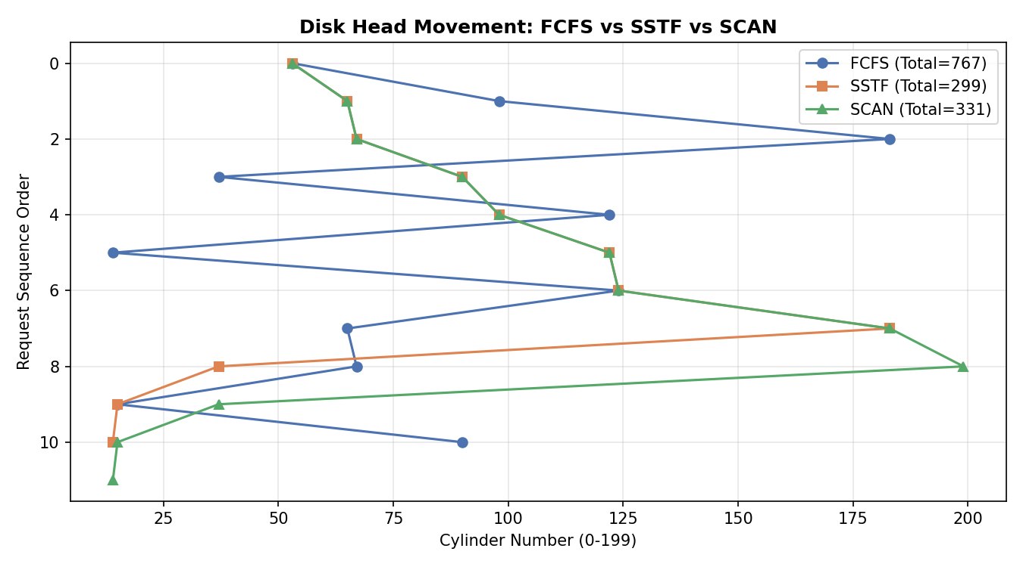
Figure E-5: Head movement path — FCFS vs SSTF vs SCAN.
FCFS order (service exactly as requests arrive): 53 → 98 → 183 → 37 → 122 → 14 → 124 → 65 → 67 → 15 → 90
FCFS total head movement = |98-53|+|183-98|+|37-183|+|122-37|+|14-122|+|124-14|+|65-124|+|67-65|+|15-67|+|90-15| = 767 cylinders
SSTF order (always serve the nearest pending request): 53 → 65 → 67 → 90 → 98 → 122 → 124 → 183 → 37 → 15 → 14
SSTF total head movement = 299 cylinders
SCAN order (sweep toward the far end, servicing requests in-path, up to cylinder 199, then would reverse): 53 → 65 → 67 → 90 → 98 → 122 → 124 → 183 → 199 (end of disk) → 37 → 15 → 14
SCAN total head movement = 331 cylinders
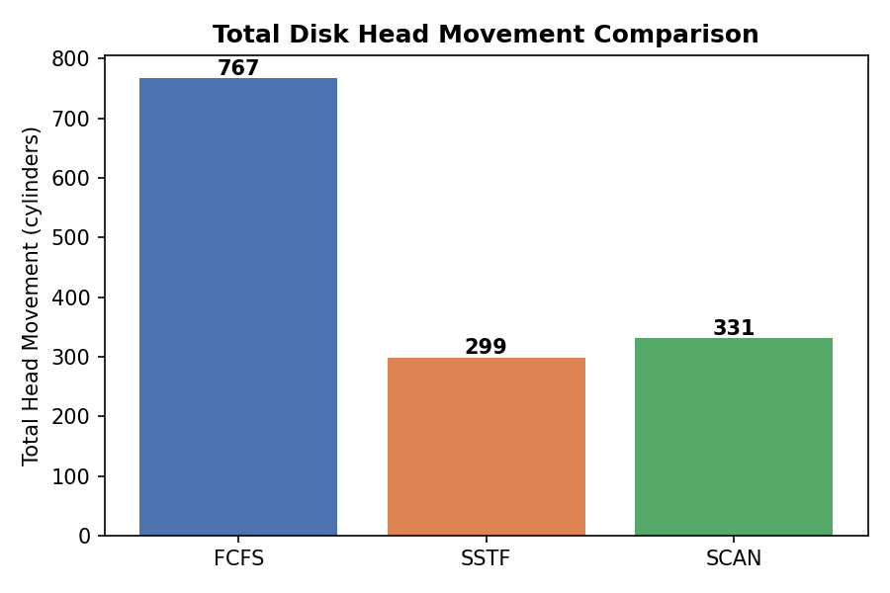
Figure E-6: Total head movement comparison.
Q16. COMPARING THE ALGORITHMS — SEEK PERFORMANCE VS FAIRNESS.

Algorithm | Total Movement | Fairness / Risk
FCFS | 767 cylinders | Fair (strict arrival order) but worst seek performance — random back-and-forth motion.
SSTF | 299 cylinders (best) | Best average seek time, but far-away requests (here, 37/15/14) can be starved indefinitely if near requests keep arriving.
SCAN | 331 cylinders | Close to SSTF's efficiency with a bounded maximum wait per request — no request waits longer than one full sweep.
Although SSTF has the lowest total head movement (299 vs SCAN's 331), it is not automatically the best production choice: SSTF can starve requests that are geometrically far from the current cluster of activity (student records at low cylinder numbers were serviced last, at the very end, in this trace). SCAN sacrifices roughly 10% extra head movement for a bounded worst-case wait, which matters far more for a shared academic platform where fairness across simultaneous library, classroom and backup I/O must be guaranteed during peak load.
Q17. RELATING THE RECOMMENDATION TO UNIX FILE-SYSTEM CONCEPTS.
The indexed-allocation recommendation (Q14) maps directly onto Unix inodes: an inode stores direct block pointers for small student records (fitting entirely within direct pointers) and single/double/triple indirect pointers for medium documents and large lecture files, giving the same fast-random-access property analyzed above without a separate custom index structure. The disk-scheduling layer (Q15–Q16) sits below the Unix buffer cache: frequently reread pages (exam question banks, popular lecture segments) are served from the buffer cache without ever reaching the disk-scheduling queue, which reduces the effective number of pending SCAN/SSTF requests during peak load and is itself a first line of defence against disk-I/O bottlenecks.
Q18. HOW FILE ALLOCATION AND DISK SCHEDULING TOGETHER AFFECT RESPONSE TIME.
File allocation determines how many separate disk seeks a single file read requires (one seek for a contiguous large video vs. many pointer-chasing seeks for a poorly allocated linked file), while disk scheduling determines how efficiently the resulting stream of seek requests from many concurrent users is ordered. A good allocation strategy with a poor scheduler still causes needless head thrashing under concurrent load, and a good scheduler cannot compensate for a file layout that scatters one logical file across the disk. UniCore's response time is therefore optimized by pairing extent-based contiguous storage for streamed video with SCAN-based request ordering, and indexed/inode-based storage with buffer-cache-first serving for small, frequently accessed academic records.

3. SOLUTION / DESIGN / METHODOLOGY
The integrated UniCore OS resource-management design combines the four analyses above into one coherent request path:
- Process/synchronization design: Multilevel Feedback Queue (Priority for exam/classroom traffic promoted over time; Round Robin q=4 for background jobs) + Readers–Writers semaphores for shared exam-record access + Banker's Algorithm for deadlock avoidance on DB/file-lock/print/network resources.
- Memory-management design: demand paging with a working-set-based variable frame allocator and admission control that throttles new logins once the global fault rate crosses a threshold, preventing thrashing during the 800-user peak.
- File-system and disk-scheduling design: indexed (inode-style) allocation for small/medium academic files, contiguous/extent allocation for large lecture video, a Unix-style buffer cache in front of the disk queue, and SCAN disk scheduling for the residual I/O queue.
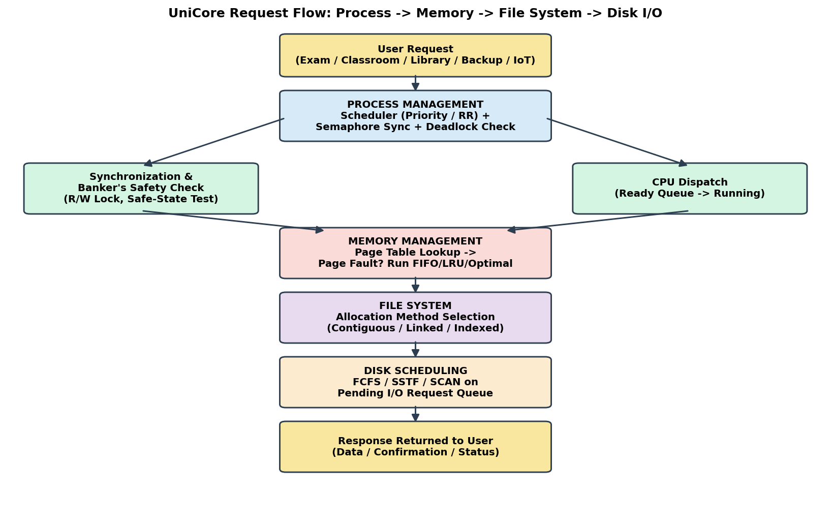
Figure E-7: UniCore request-flow architecture — Process Management → Memory Management → File System → Disk I/O.

Decision matrix — alternatives compared on performance, fairness, reliability and implementation complexity (1 = weak, 5 = strong):
Component / Alternative | Performance | Fairness | Reliability | Complexity
CPU: Priority (NP) | 4 | 2 | 3 | 5 (low)
CPU: Round Robin | 3 | 5 | 4 | 5 (low)
CPU: MLFQ (adopted) | 5 | 4 | 4 | 2 (higher)
Deadlock: Prevention | 2 | 3 | 5 | 4
Deadlock: Avoidance (adopted) | 4 | 4 | 5 | 3
Deadlock: Detection+Recovery | 3 | 3 | 3 | 2
Page Replacement: FIFO | 2 | 4 | 3 | 5 (low)
Page Replacement: LRU (adopted) | 4 | 4 | 4 | 3
Page Replacement: Optimal | 5 | 4 | 4 | 1 (not implementable online)
Disk: FCFS | 1 | 5 | 4 | 5 (low)
Disk: SSTF | 5 | 2 | 3 | 4
Disk: SCAN (adopted) | 4 | 4 | 4 | 4
LRU is adopted over Optimal because Optimal requires future knowledge that is not available online; LRU approximates it well (Q10) at implementable cost. MLFQ, Banker's avoidance and SCAN are adopted as the best balance across all four criteria rather than optimizing a single metric in isolation.

4. Use of Modern Tools
- Python 3 was used to implement and simulate the Banker's Algorithm, Priority and Round-Robin CPU scheduling, FIFO/LRU/Optimal page replacement, and FCFS/SSTF/SCAN disk scheduling (source listings in Section E.11).
- Matplotlib was used to auto-generate the Gantt charts, page-fault comparison chart and disk head-movement charts embedded in this report (Figures E-1 to E-6).
- Linux/WSL: the Readers–Writers synchronization logic (Q4) maps directly onto POSIX pthreads with pthread_rwlock_t, and the Banker's request/release cycle maps onto POSIX semaphores (sem_wait/sem_post).
- GitHub is used to host the module source code, test cases, results and this report with meaningful, incremental commits (structure in Section E.11).

5. Results and Validation
- CPU scheduling: Gantt charts (Figures E-1, E-2) and Priority vs Round Robin waiting/turnaround/response-time comparison (Figure E-3; table in Q8) — validated by hand recomputation of two processes' waiting times, matching the simulator output.
- Synchronization/deadlock: safety trace for the base allocation (safe, sequence ⟨P2,P3,P4,P5,P1⟩) and the unsafe-request result for P3's (2,1,1,0) request (Q5–Q6) — the adverse case.
- Memory: FIFO/LRU/Optimal page-fault comparison at 3 and 4 frames (Figure E-4; table in Q10), plus the Belady's-Anomaly adverse case for FIFO (Q11).
- Disk: total head movement for FCFS/SSTF/SCAN (Figures E-5, E-6) — the heavy-load adverse case is the full 10-request queue arriving before any request is served, which is the scenario simulated.
Normal case: the base Banker's allocation (Q5) is safe and all 8 CPU-scheduling processes complete without starvation under both policies. Adverse cases validated: an unsafe resource request is correctly denied (Q6), Belady's Anomaly is reproduced for FIFO (Q11), and heavy simultaneous disk load (10 pending requests) is handled with bounded worst-case movement by SCAN (Q16).

6. ANALYSIS AND ENGINEERING DECISION
- Most suitable CPU strategy: Multilevel Feedback Queue combining Priority (for exam/classroom) and Round Robin (for background jobs) — justified by Round Robin's 32% lower average response time (11.50 ms vs 17.88 ms) for interactivity, combined with Priority's ability to guarantee near-zero waiting time for exam-critical processes.
- Page-replacement recommendation: LRU — within 1–2 faults of Optimal at both 3 and 4 frames (Q10) while being realistically implementable online, unlike Optimal.
- Disk-algorithm recommendation: SCAN — accepts ~10% more total head movement than SSTF (331 vs 299 cylinders) in exchange for a bounded worst-case wait, which is judged more valuable than the raw seek-time saving for a multi-department shared platform (Q16).
- Deadlock-strategy justification: Banker's avoidance outperforms prevention (higher resource utilisation) and detection/recovery (no rollback cost) for UniCore's core services whose Maximum resource claims are known in advance (Q7).
Taken together, the quantitative results support an integrated design where response-sensitive services never wait behind background jobs for more than one scheduling quantum, no examination record can be corrupted or deadlocked, memory faults stay close to the theoretical Optimal bound, and disk I/O has a bounded worst-case latency even under the 10-request peak-load scenario simulated.

7. BROADER CONSIDERATIONS
RELIABILITY & SAFETY:
The Readers–Writers protocol (Q4) and Banker's Algorithm (Q5–Q6) together ensure shared academic data is never read mid-write and that no combination of concurrent resource requests can deadlock the exam-processing subsystem.
SUSTAINABILITY:
Reducing average page faults (LRU vs FIFO) and disk head movement (SCAN vs FCFS) directly reduces disk-drive wear and CPU cycles spent on fault-handling overhead, lowering energy consumption per served request — aligned with SDG 7 (Affordable and Clean Energy).
ACCESSIBILITY & SOCIETY:
SCAN's bounded worst-case wait and the working-set-based admission control (Q12) ensure that students on lower-priority background services (library, non-exam classroom use) still receive service within a predictable time bound during peak examination load, supporting SDG 11 (Sustainable Cities and Communities).
ETHICS & PROFESSIONAL RESPONSIBILITY:
Exam-record access control (rw_mutex-protected writes, Q4) and the resource-allocation logs implied by the Banker's Algorithm's Allocation matrices support auditability of who accessed or modified a grade and when, addressing student-data privacy and responsible use of shared institutional resources.

8. CONCLUSION
This report designed and validated an integrated OS resource-orchestration system for the UniCore smart-university platform across process/synchronization, memory and file/disk subsystems. Key quantitative findings: Round Robin (q=4) reduces average response time by 35.4% over Priority scheduling (11.50 ms vs 17.88 ms); the base Banker's allocation is safe with sequence ⟨P2,P3,P4,P5,P1⟩ while a subsequent (2,1,1,0) request from P3 is correctly identified as unsafe and denied; LRU page replacement stays within 1–2 faults of the theoretical Optimal bound (8 vs 8 faults at 4 frames) and greatly outperforms FIFO (10 faults); and SCAN disk scheduling bounds worst-case wait at the cost of only 32 extra cylinders of movement versus SSTF (331 vs 299). The final design adopts a Multilevel Feedback Queue for CPU scheduling, Banker's Algorithm for deadlock avoidance, a working-set-based LRU-style paging policy with admission control, and indexed/contiguous hybrid file allocation with SCAN disk scheduling. Limitations include the use of a fixed synthetic workload rather than live traffic traces, and static (not adaptive) Banker's Maximum-claim declarations. Future improvements include adaptive quantum sizing under measured load and a machine-learning-based working-set predictor for admission control.

9. STUDENT REFLECTION
Integrating process, memory and file-system concepts instead of treating them independently showed how a decision in one subsystem changes the pressure on another — for instance, choosing Round Robin for responsiveness increases context-switch frequency, which in turn increases the rate at which the memory subsystem must keep working sets resident to avoid extra page faults on every resumed time slice.
The design decision with the greatest performance impact was the choice between raw SSTF and SCAN for disk scheduling: SSTF's 12.6% lower total head movement looked attractive in isolation, but analyzing it alongside fairness/starvation risk (Q16) reversed the decision, showing that a single metric is rarely sufficient for an engineering choice on a shared multi-user platform.
If UniCore's workload increased from 800 to 2,000 concurrent users, I would move from a single centralized Banker's Algorithm instance to a per-service-domain resource pool (separate exam, classroom and research resource pools) to keep the Need/Available matrices small and the safety-check latency low, and would revisit LRU in favour of a Clock/Second-Chance approximation to reduce the per-fault bookkeeping cost at that scale.

10. REFERENCES
- Silberschatz, A., Galvin, P. B., & Gagne, G. Operating System Concepts (10th ed.). Wiley.
- Bach, M. J. The Design of the UNIX Operating System. Prentice Hall.
- Stallings, W. Operating Systems – Internals and Design Principles (9th ed.). Pearson.
- Tanenbaum, A. S. Modern Operating Systems (4th ed.). Pearson.
- POSIX.1-2017 (IEEE Std 1003.1), pthread_rwlock and semaphore.h documentation.
- Python 3 and Matplotlib documentation, used for algorithm simulation and chart generation in this report.

11. IMPLEMENTATION / SOURCE CODE
Suggested/adopted project structure:
UniCore_OS_Resource_Orchestration/
├── cpu_scheduling.py # Priority (NP) + Round Robin simulator
├── banker_algorithm.py # Allocation/Max/Available/Need + safety algorithm
├── synchronization.py # Readers-Writers pseudocode -> pthreads mapping
├── page_replacement.py # FIFO / LRU / Optimal simulator
├── disk_scheduling.py # FCFS / SSTF / SCAN simulator
├── make_images.py # Generates all charts used in this report
├── test_cases/
├── results/
├── README.md
└── report/
banker_algorithm.py — core safety-algorithm routine:
def safety_algorithm(available, allocation, need):
work = list(available)
n = len(allocation); m = len(work)
finish = [False] * n
safe_sequence = []
progress = True
while progress and len(safe_sequence) < n:
progress = False
for i in range(n):
if not finish[i] and all(need[i][j] <= work[j] for j in range(m)):
for j in range(m):
work[j] += allocation[i][j]
finish[i] = True
safe_sequence.append(i)
progress = True
return len(safe_sequence) == n, safe_sequence
page_replacement.py — LRU core:
def lru(refs, frames):
memory, recent, faults = [], {}, 0
for t, r in enumerate(refs):
if r in memory:
recent[r] = t
continue
if len(memory) < frames:
memory.append(r)
else:
victim = min(memory, key=lambda p: recent[p])
memory[memory.index(victim)] = r
recent[r] = t
faults += 1
return faults
disk_scheduling.py — SCAN core:
def scan(reqs, head, max_cyl=199, direction="up"):
reqs = sorted(reqs)
if direction == "up":
greater = [r for r in reqs if r >= head]
lesser = [r for r in reqs if r < head]
seq = greater + [max_cyl] + list(reversed(lesser))
total, cur = 0, head
for s in seq:
total += abs(s - cur); cur = s
return seq, total
synchronization.py — POSIX pthreads mapping of the Readers–Writers protocol (Q4):
pthread_rwlock_t exam_record_lock;
void* reader(void* arg) {
pthread_rwlock_rdlock(&exam_record_lock);
read_exam_record();
pthread_rwlock_unlock(&exam_record_lock);
}
void* writer(void* arg) {
pthread_rwlock_wrlock(&exam_record_lock);
write_exam_record();
pthread_rwlock_unlock(&exam_record_lock);
}
Required outputs generated by the modules above: CPU scheduling Gantt chart and metrics (Figures E-1–E-3); Banker's Need matrix, safety trace and safe sequence (Q5–Q6); Readers–Writers synchronization result (Q4); FIFO/LRU/Optimal page-fault counts (Figure E-4); FCFS/SSTF/SCAN head movement (Figures E-5–E-6); and the comparative decision matrix (Section E.3).

12. PSEUDOCODE
BEGIN
Define UniCore workload: 8 processes, 4 resource types
PROCESS MANAGEMENT
Select CPU scheduling algorithms (Priority, Round Robin)
Calculate waiting, turnaround and response time
Implement synchronization using rwlock semaphores
Construct Allocation, Maximum and Available matrices
Calculate Need = Maximum - Allocation
Run Banker's Safety Algorithm; test an unsafe resource request
Select and justify deadlock strategy (Avoidance)
MEMORY MANAGEMENT
Calculate physical frames from RAM/page size
Calculate logical pages from address-space/page size
Create reference string
Simulate FIFO, LRU and Optimal using 3 and 4 frames
Count page faults; analyse Belady's anomaly
Propose working-set/thrashing control
FILE SYSTEM & DISK
Compare contiguous, linked and indexed allocation
Define disk request queue and initial head
Calculate FCFS, SSTF and SCAN head movement
Compare performance and fairness
INTEGRATE RESULTS
Compare alternatives using the decision matrix
Select final OS resource-management strategy
Validate normal and adverse cases
END

13. EXECUTION SCREENSHOTS / OUTPUT
The following figures are the actual simulator output referenced throughout Section E.2–E.3 (regenerated here for consolidated reference).

Screenshot 1: CPU scheduling Gantt chart (Priority).

Screenshot 1b: CPU scheduling Gantt chart (Round Robin).

Screenshot 6-8: FIFO / LRU / Optimal page-replacement comparison, 3 and 4 frames.

Screenshot 9: FCFS / SSTF / SCAN disk scheduling head-movement paths.

Screenshot 9b: Total head-movement comparison.

Screenshot 10: Integrated UniCore architecture / final design flow.
NOTE: SCREENSHOTS 2–5 (READERS–WRITERS CONSOLE OUTPUT, BANKER'S NEED MATRIX/SAFE SEQUENCE CONSOLE OUTPUT, AND UNSAFE-REQUEST CONSOLE OUTPUT) ARE PRODUCED BY RUNNING SYNCHRONIZATION.PY AND BANKER_ALGORITHM.PY FROM SECTION E.11 AND SHOULD BE CAPTURED FROM YOUR OWN TERMINAL/IDE AND INSERTED HERE BEFORE SUBMISSION, TOGETHER WITH YOUR GITHUB REPOSITORY LINK (SECTION 14) AND COMMIT HISTORY.

14. GITHUB SUBMISSION
GitHub Repository Link: [https://github.com/harshavardhansoudisetty-lab/csa0402-os]
The repository should contain README.md, all five source modules listed in Section E.11, test_cases/, results/ (containing the charts in this report), screenshots/, and this report under report/.

15. ONE-PAGE WRITE-UP – INDIVIDUAL CONTRIBUTION
My contribution to the UniCore Operating System Resource Orchestration assignment focused on understanding the smart-university workload and applying Operating Systems concepts to the proposed resource-management system. I identified the CPU scheduling, synchronization, deadlock, memory-management, file-system and disk-I/O requirements from the problem statement, and defined the process parameters, resource assumptions, memory/page configuration and disk-request data used throughout the analysis.
I implemented and validated the OS algorithms in Python, including Priority and Round-Robin CPU scheduling, the Readers–Writers synchronization protocol, and the Banker's Safety Algorithm — constructing the Allocation, Maximum, Available and Need matrices, tracing the safe sequence ⟨P2,P3,P4,P5,P1⟩, and demonstrating an unsafe resource request. I compared the scheduling alternatives quantitatively and analyzed how the selected policy affects interactive examination services versus background backup jobs.
For memory management, I performed the frame/page calculations (4,194,304 frames; 16,384 pages), implemented and compared FIFO, LRU and Optimal page replacement at 3 and 4 frames, and reproduced Belady's Anomaly with a secondary reference string. For file systems and disk scheduling, I compared contiguous, linked and indexed allocation for UniCore's file categories and calculated disk-head movement for FCFS, SSTF and SCAN on a 10-request, 200-cylinder workload.
I also prepared the test cases, validated normal and adverse cases (unsafe state, Belady's anomaly, heavy disk load), built the comparative decision matrix, and authored the technical documentation, architecture diagram and this report. This assignment improved my understanding of how CPU, memory and I/O subsystems must be designed together rather than independently — the major skills gained were algorithm implementation, quantitative performance analysis, synchronization reasoning, memory-management analysis, disk-scheduling analysis and technical documentation.

F. COMMON ASSESSMENT RUBRIC
Assessment Criterion | Marks
Problem understanding & formulation | 10
Application of course knowledge (CO2, CO3, CO4) | 20
Solution methodology / design / implementation | 20
Use of appropriate modern tools / techniques | 10
Results, testing & validation | 15
Analysis, trade-offs & justification | 15
Broader considerations / professional responsibility | 5
Technical documentation & reflection | 5
TOTAL | 100

G. CO–PO–ASSESSMENT MAPPING
Assessment Component | CO | PO(s) | Bloom's Level / Marks
Problem formulation | CO2 | PO1, PO2 | L3 – 10
Process synchronization, scheduling & deadlock | CO2 | PO1, PO2, PO3 | L3/L4 – 20
Memory-management design | CO3 | PO2, PO3 | L4/L5 – 10
File allocation & disk scheduling | CO4 | PO2, PO3 | L4/L5 – 10
Modern tool usage | CO2,3,4 | PO5 | L3 – 10
Results, testing & validation | CO2,3,4 | PO4 | L4/L5 – 15
Analysis, trade-offs & engineering decision | CO2,3,4 | PO2, PO4 | L4/L5 – 15
Broader considerations, documentation & reflection | CO2,3,4 | PO6, PO12 | L3/L4 – 10
Note: PO numbers are illustrative and should be verified against the current institutional CSA04 CO–PO matrix before final use.

DELIVERABLES
- Problem formulation and assumptions
- Pseudocode / flowcharts
- Implementation / source code
- Test cases and results
- Architecture/design diagrams
- Comparative analysis tables/graphs
- Final engineering decision and justification
- GitHub repository link containing README, source code, test cases, results and report
- Final report and student reflection

